37.17: Eq. (37.18): 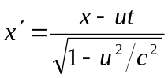 Eq. (37.19): 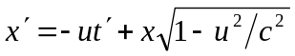
Equate: 